How to configure Bandwidth Limiter using Traffic shaper

1. Browse to firewall / select the Traffic shaper.
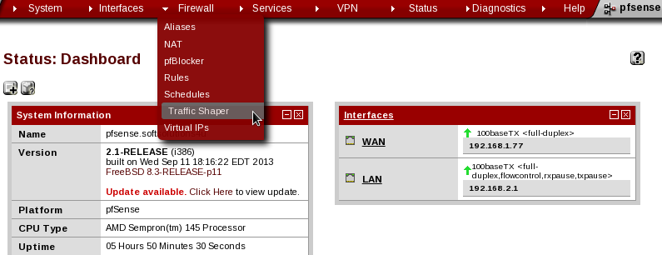

2. To choose the Limiter tab.

3. Click a plus button to create a new traffic shaper limiter.
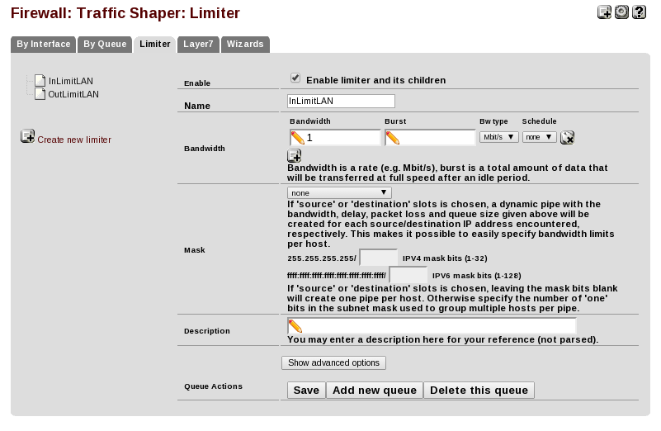

4. To click the check box for enable the limiter
5. Add the name for bandwidth limiter, and set the bandwidth limit save the changes.
6. Browse the firewall, select the Lan rules.
7. Click a plus button to careate new lan rules for bandwidth limiter
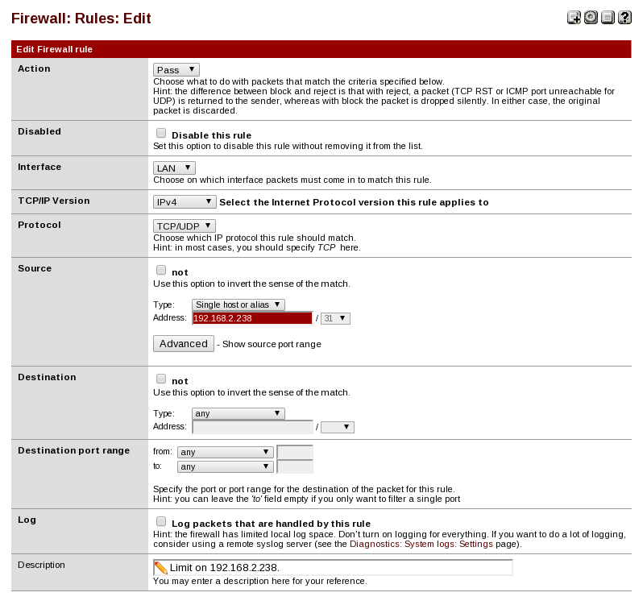
8. Select the action type, to set the soruce IP address of bandwidth limiter.

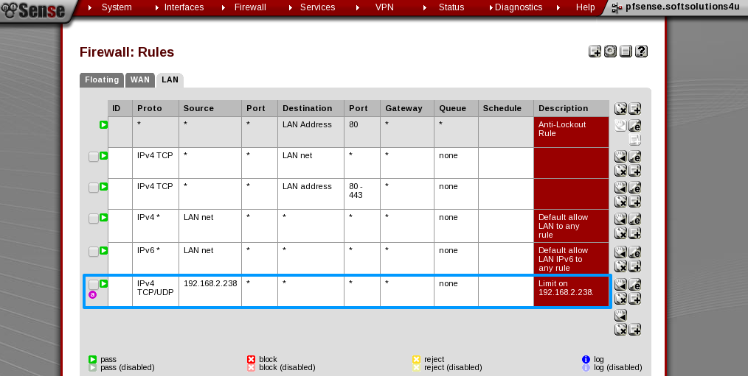

9. Go to In/out options to set the upload and download bandwidth limit under the advanced futures of lan rule.
10. finally save the changes and apply the changes.

